

# Chapter 8. Numeral Systems

Prof:Muzafer Shala

Ass:Laberion Zebica Student:Adhurim Haziri

Kampusi:Ferizaj

### Convert the numbers **151**, **35**, **43**, **251**, **1023**and **1024** to the **binary numeral system**.

using System;

namespace detyra1

{

class Program

{

static void Main(string[] args)

{

Console.WriteLine("150 to binary {0}.", Convert.ToString(150, 2));

Console.WriteLine("35 to binary {0}.", Convert.ToString(35, 2));

Console.WriteLine("43 to binary {0}.", Convert.ToString(43, 2));

Console.WriteLine("251 to binary {0}.", Convert.ToString(251, 2));

}

}

}

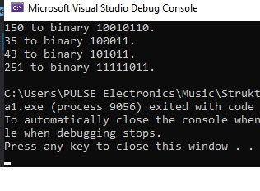

### Convert the number **1111010110011110(2)** to **hexadecimal** and **decimal** numeral systems.

using System;

namespace detyra2

{

class Program

{

static void Main(string[] args)

{

Console.WriteLine("1111010110011110 to decimal is {0}.",

Convert.ToInt64("1111010110011110", 2));

Console.WriteLine("1111010110011110 to hexadecimal is {0}.",

Convert.ToInt64("1111010110011110", 2).ToString("X"));

}

}

}

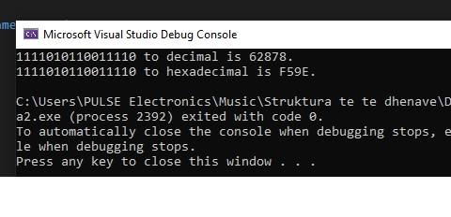

### Convert the hexadecimal numbers **FA**, **2A3E**, **FFFF**, **5A0E9** to **binary** and **decimal** numeral systems.

using System;

namespace detyra3

{

class Program

{

static void conversion(string value)

{

Console.WriteLine("{0} to decimal is {1}.",

value, Convert.ToInt32(value, 16));

Console.WriteLine("{0} to decimal is {1}.\n", value,

Convert.ToString(Convert.ToInt32(value, 16), 2));

}

static void Main(string[] args)

{

conversion("2A3E");

conversion("FA");

conversion("FFFF");

conversion("5A0E9");

}

}

}

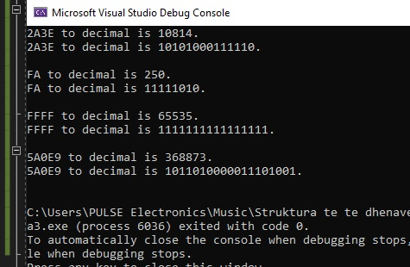

### Write a program that converts a **decimal number to binary** one.

using System;

namespace detyra4

{

class Program

{

static void Main(string[] args)

{

Console.Write("Enter decimal number: ");

int decimali = Int32.Parse(Console.ReadLine());

Console.WriteLine("{0} to binary is {1}.",

decimali, decimali.ToString(decimali, 2));

}

}

}

### Write a program that converts a **binary number to decimal** one.

using System;

namespace detyra5

{

class Program

{

static void Main(string[] args)

{

Console.Write("Enter binary number: ");

string binary = Console.ReadLine();

Console.WriteLine("{0} to decimal is {1}.",

binary, Convert.ToInt64(binary, 2));

}

}

}

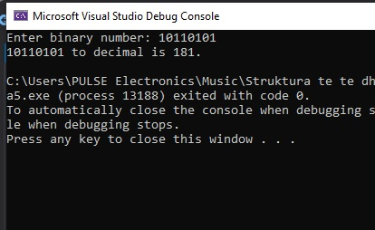

### Write a program that converts a **decimal number to hexadecimal** one.

using System;

namespace detyra6

{

class Program

{

static void Main(string[] args)

{

Console.Write("Enter decimal number: ");

int deci = Int32.Parse(Console.ReadLine());

Console.WriteLine("{0} to hexadecimal is {1}.",

deci, deci.ToString("X"));

}

}

}

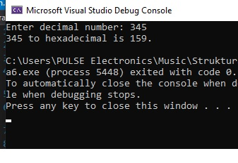

### Write a program that converts a **hexadecimal number to decimal** one.

using System;

namespace detyra7

{

class Program

{

static void Main(string[] args)

{

Console.Write("Enter hexadecimal number: ");

string hexa = Console.ReadLine();

Console.WriteLine("{0} to decimal is {1}.",

hexa, Convert.ToInt32(hexa, 16));

}

}

}

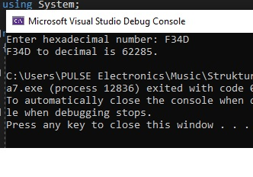

### Write a program that converts a **hexadecimal number to binary** one.

using System;

namespace detyra8

{

class Program

{

static void Main(string[] args)

{

Console.Write("Enter hexadecimal number: ");

string hexa = Console.ReadLine();

Console.WriteLine("{0} to binary is {1}.",

hexa, Convert.ToString(Convert.ToInt32(hexa, 16), 2));

}

}

}

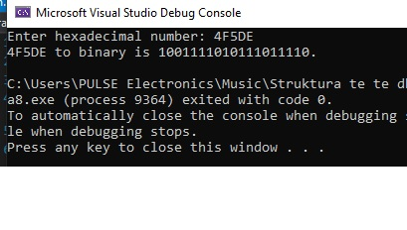

### Write a program that converts a **binary number to hexadecimal** one.

using System;

namespace detyra9

{

class Program

{

static void Main(string[] args)

{

Console.Write("Enter binary number: ");

string binary = Console.ReadLine();

Console.WriteLine("{0} to hexadecimal is {1}.",

binary, Convert.ToInt32(binary, 2).ToString("X"));

}

}

}

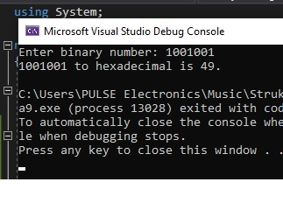

### 10.   Write a program that converts a **binary number to decimal** using the Horner scheme.

using System;

namespace detyra10

{

class Program

{

static void Main(string[] args)

{

int deci = 0;

Console.Write("Enter binary number: ");

string binary = Console.ReadLine();

int length = binary.Length;

int power = length - 1;

for (int i = 0; i < length; i++)

{

deci += (int)(int.Parse(binary[i].ToString()) * Math.Pow(2, power));

power--;

}

Console.WriteLine("Result is {0}.", deci);

}

}

}

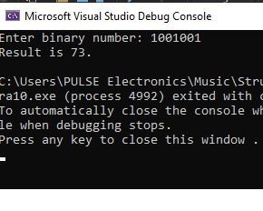

### 11.   Write a program that converts **Roman digits to Arabic** ones.

using System;

using System.Collections.Generic;

using System.Linq;

using System.Text;

using System.Threading.Tasks;

namespace detyra11

{

class Program

{

static void Main(string[] args)

{

int result = 0;

Console.Write("Enter Roman number: ");

String s = Console.ReadLine();

string[] chars = s.Select(c => c.ToString()).ToArray();

for (int i = 0; i < chars.Length; i++)

{

if (chars[i] == "m" || chars[i] == "M") result += 1000;

if (chars[i] == "d" || chars[i] == "D") result += 500;

if (chars[i] == "c" || chars[i] == "C")

{

result += 100;

if (i < chars.Length - 1)

{

if (chars[i + 1] == "d" || chars[i + 1] == "D") result -= 200;

if (chars[i + 1] == "m" || chars[i + 1] == "M") result -= 200;

}

}

if (chars[i] == "l" || chars[i] == "L") result += 50;

if (chars[i] == "x" || chars[i] == "X")

{

result += 10;

if (i < chars.Length - 1)

{

if (chars[i + 1] == "l" || chars[i + 1] == "L") result -= 20;

if (chars[i + 1] == "c" || chars[i + 1] == "C") result -= 20;

}

}

if (chars[i] == "v" || chars[i] == "V") result += 5;

if (chars[i] == "i" || chars[i] == "I")

{

result++;

if (i < chars.Length - 1)

{

if (chars[i + 1] == "v" || chars[i + 1] == "V") result -= 2;

if (chars[i + 1] == "x" || chars[i + 1] == "X") result -= 2;

}

}

}

Console.WriteLine("Arabic number is " + result);

}

}

}

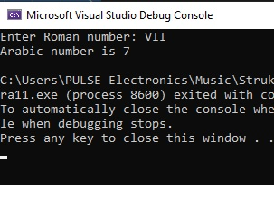

### 12.   Write a program that converts **Arabic digits to Roman** ones.

using System;

namespace detyra12

{

class Program

{

static void Main(string[] args)

{

String result = "";

Console.Write("Enter Arabic number: ");

int i = Convert.ToInt32(Console.ReadLine());

int thousands = i / 1000, hundreds = (i / 100) % 10, tens = (i / 10) % 10, ones = i % 10;

switch (thousands)

{

case 1: result += "M"; break;

case 2: result += "MM"; break;

case 3: result += "MMM"; break;

}

switch (hundreds)

{

case 1: result += "C"; break;

case 2: result += "CC"; break;

case 3: result += "CCC"; break;

case 4: result += "CD"; break;

case 5: result += "D"; break;

case 6: result += "DC"; break;

case 7: result += "DCC"; break;

case 8: result += "DCCC"; break;

case 9: result += "CM"; break;

}

switch (tens)

{

case 1: result += "X"; break;

case 2: result += "XX"; break;

case 3: result += "XXX"; break;

case 4: result += "XL"; break;

case 5: result += "L"; break;

case 6: result += "LX"; break;

case 7: result += "LXX"; break;

case 8: result += "LXXX"; break;

case 9: result += "XC"; break;

}

switch (ones)

{

case 1: result += "I"; break;

case 2: result += "II"; break;

case 3: result += "III"; break;

case 4: result += "IV"; break;

case 5: result += "V"; break;

case 6: result += "VI"; break;

case 7: result += "VII"; break;

case 8: result += "VIII"; break;

case 9: result += "IX"; break;

}

Console.WriteLine("Roman number is " + result);

}

}

}

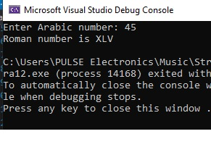

### 13.   Write a program that by given **N**, **S**, **D** (**2** **≤** **S**, **D** **≤** **16**) converts the number **N** from an **S**-based numeral system to a **D**based numeral system.

using System;

namespace detyra13

{

class Program

{

static void Main(string[] args)

{

int s, d;

Console.Write("Enter N: ");

string n = Console.ReadLine();

do

{

Console.Write("Enter S (S == 2, 8, 10 or 16): ");

s = Int32.Parse(Console.ReadLine());

} while (s != 2 && s != 8 && s != 10 && s != 16);

do

{

Console.Write("Enter D (D == 2, 8, 10 or 16): ");

d = Int32.Parse(Console.ReadLine());

} while (d != 2 && d != 8 && d != 10 && d != 16);

n = Convert.ToString(Convert.ToInt32(n, s), d);

Console.WriteLine("Result is {0}.", n);

}

}

}

### 14.   Try **adding up 50,000,000 times the number 0.000001**. Use a loop and addition (not direct multiplication). Try it with **float** and **double** and after that with **decimal**. Do you notice the **huge difference in the results** and speed of calculation? Explain what happens.

using System;

namespace detyra14

{

class Program

{

static void Main(string[] args)

{

float n1 = 1.234f;

double n2 = 1.234;

decimal n3 = 1.234m;

Console.WriteLine(n1);

Console.WriteLine(n2);

Console.WriteLine(n3);

Console.WriteLine(n1.GetType());

Console.WriteLine(n2.GetType());

Console.WriteLine(n3.GetType());

}

}

}

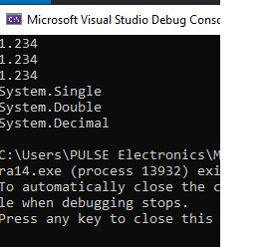

### 15.   * Write a program that prints the value of the **mantissa**, the **sign of the mantissa** and **exponent** in **float** numbers (32-bit numbers with a floating-point according to the **IEEE 754** standard). Example: for the number **-27.25** should be printed: **sign** = **1**, **exponent** = **10000011**, **mantissa** = **10110100000000000000000**.

using System;

using System.Collections.Generic;

using System.Linq;

using System.Text;

using System.Threading.Tasks;

namespace detyra15

{

class Program

{

public static string ToExactString(double d)

{

long bits = BitConverter.DoubleToInt64Bits(d);

bool negative = (bits & (1L << 63)) != 0;

int exponent = (int)((bits >> 52) & 0x7ffL);

long mantissa = bits & 0xfffffffffffffL;

if (exponent == 0)

{

exponent++;

}

else

{

mantissa = mantissa | (1L << 52);

}

exponent -= 1075;

if (mantissa == 0)

{

return negative ? "-0" : "0";

}

while ((mantissa & 1) == 0)

{

mantissa >>= 1;

exponent++;

}

}

}

}